**lawyer**

**PROJECT GROUP MEMBER**

|  |  |
| --- | --- |
| **Students Id** | **Students Name** |
| ***Student1431528*** | ***Muhammad Saad*** |
| ***Student1429988*** | ***Samiullah*** |
| ***Student1429139*** | ***Muhammad Zulqarnain*** |
| ***Student1358220*** | ***Muhammad Ali*** |

**CURRICULUM BATCH**

**7062 2211b1**

**FACULTY**

**SIR EBAD-UDDIN**

**CO-ORDINATOR**

**MISS MUNNAZAH**

**CERTIFICATE**

This is to certify that the dissertation entitled **“lawyer”** is ***Muhammad Saad* *Student1431528*, *Sami Ansari* *Student1429988*, *Muhammad Zulqarnain* *Student1429139* and *Muhammad Ali* *Student1358220*** in their partial fulfilment of the requirement of the award of the Aptech Computer Certified.

**ADMIN PANEL:**

**ADMIN LOGIN**

Here You can Login in Your Admin Account.

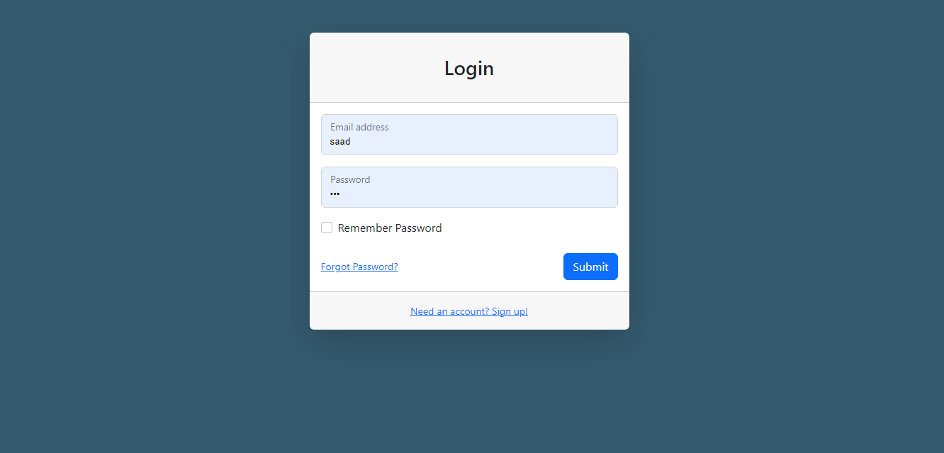

**ADMIN LAWYER**

**REGISTER**

Here You can LAWYER REGISTER in Your Admin Account.

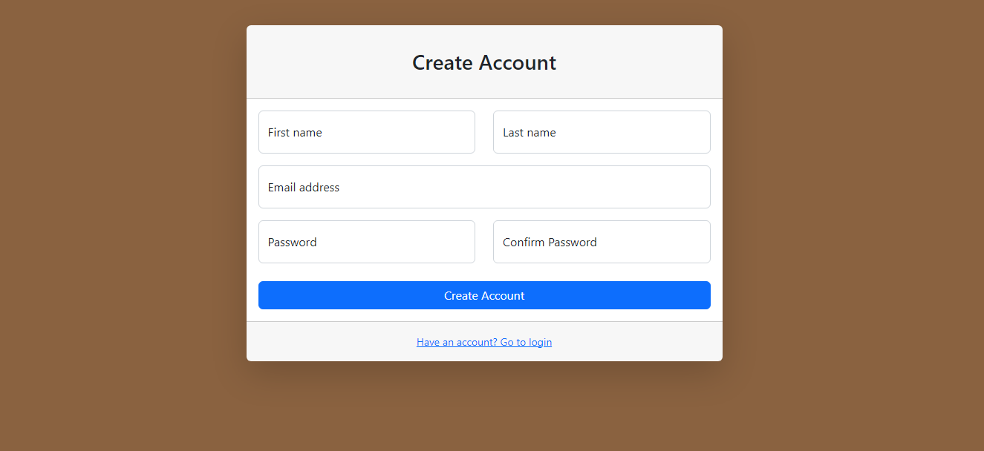

**HOME:**

Admin can read the details of login users.

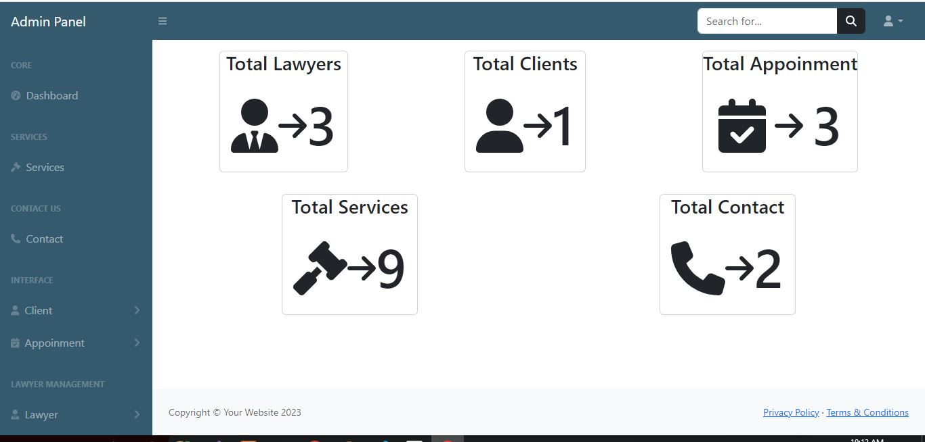

**ADD LAWYER:**

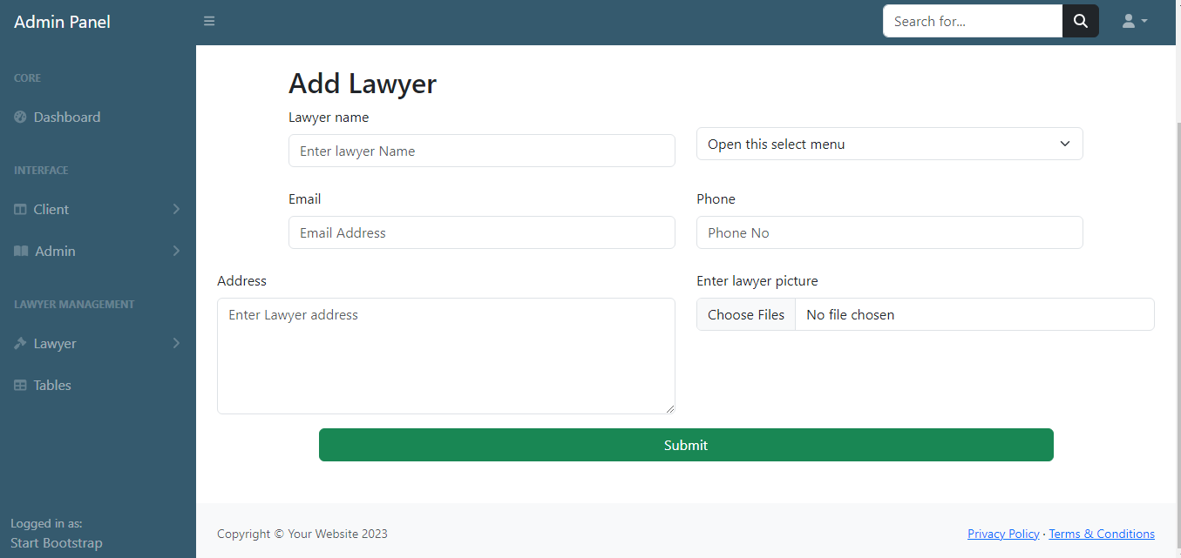

**VIEW LAWYER:**

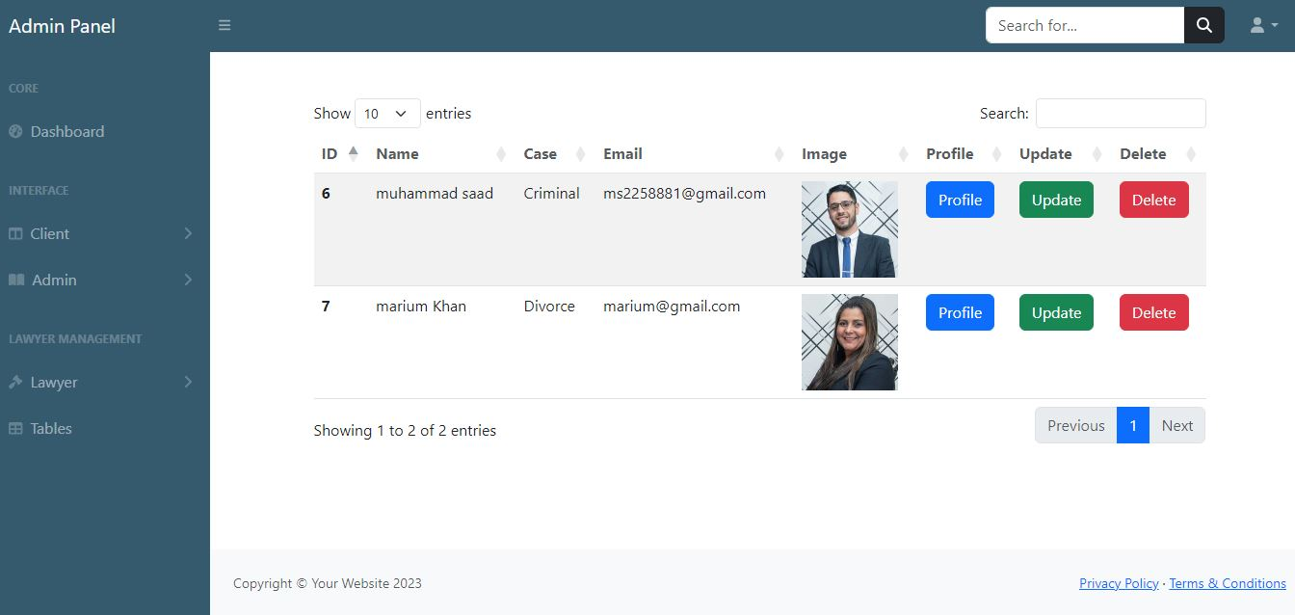

**ADD CLIENT:**

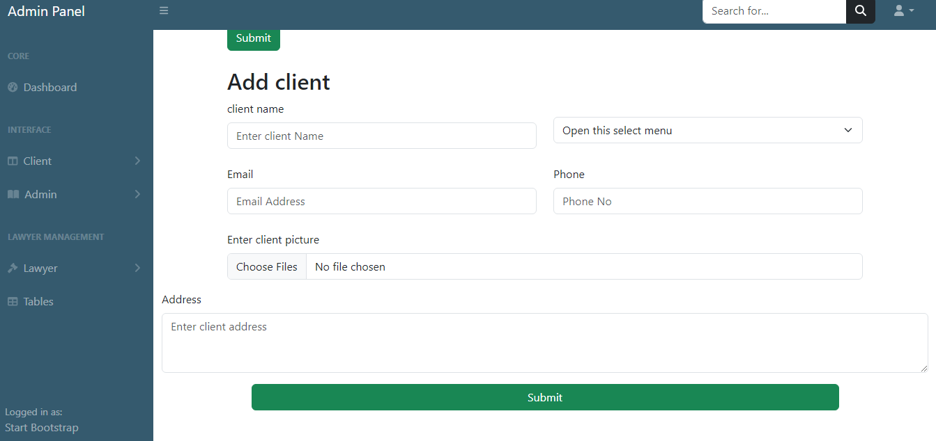

**VIEW CLIENT:**

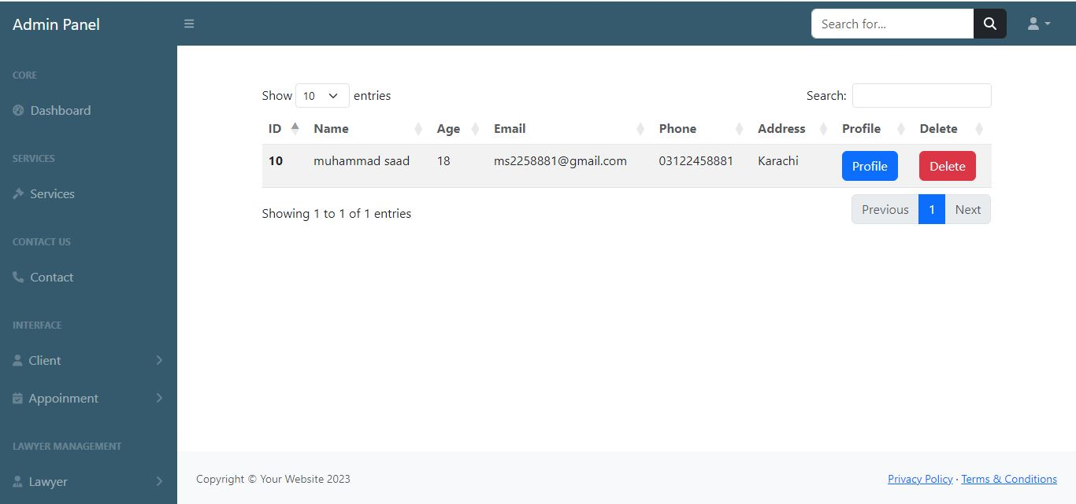

**CONTACT**

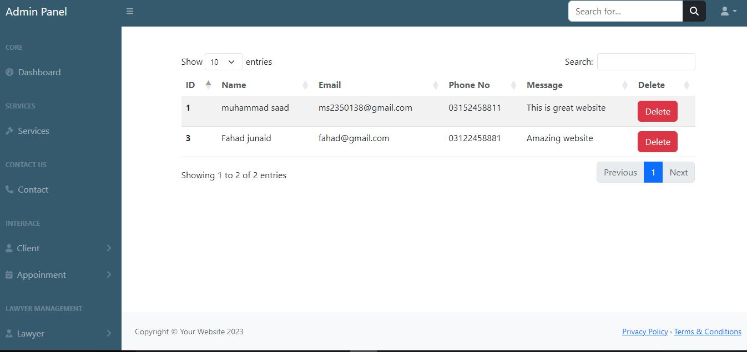

**VIEW APPOINMENT**

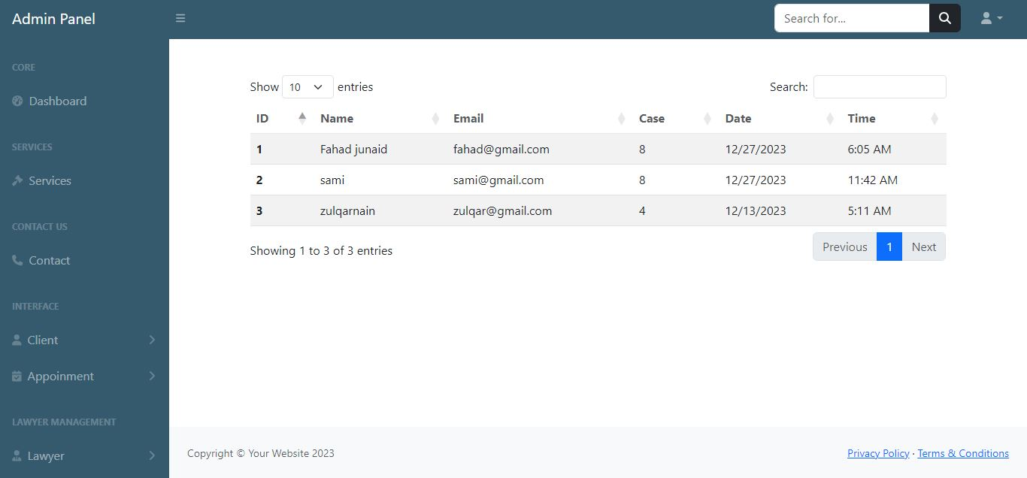

**SERVICES**

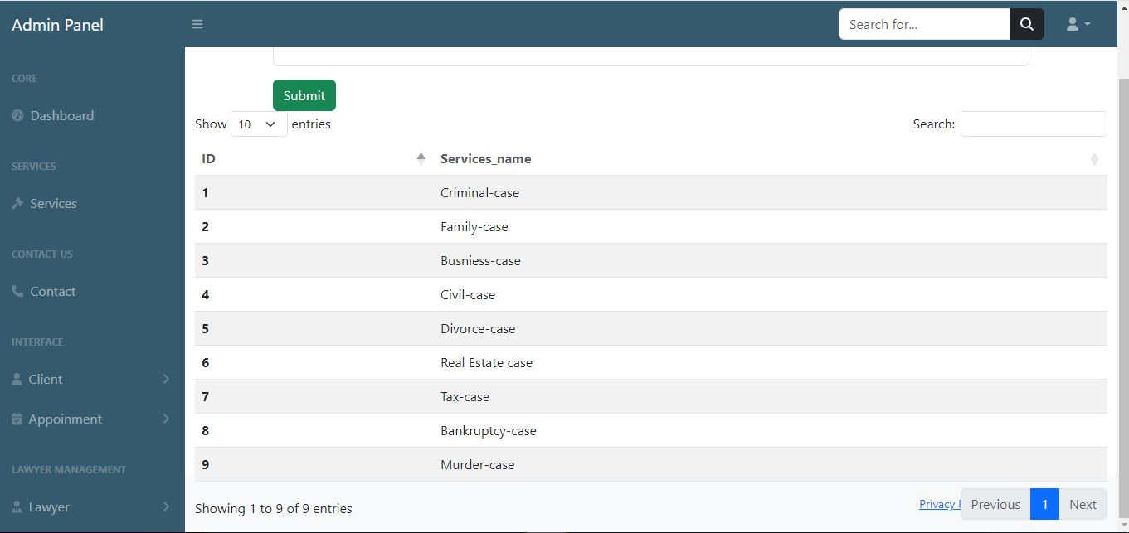

**LAWYER PANEL**

**LAWYER HOME**

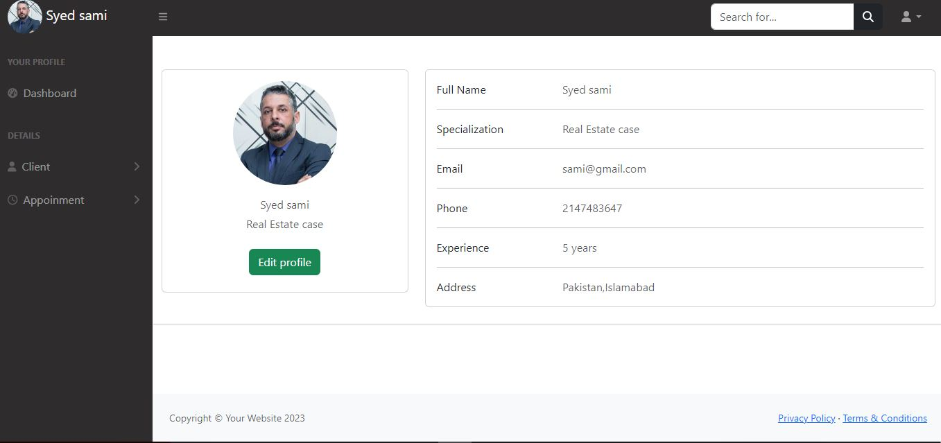

**VIEW APPOINMENT**

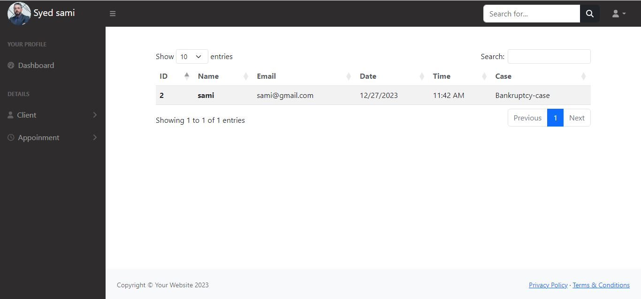

**VIEW CLIENT**

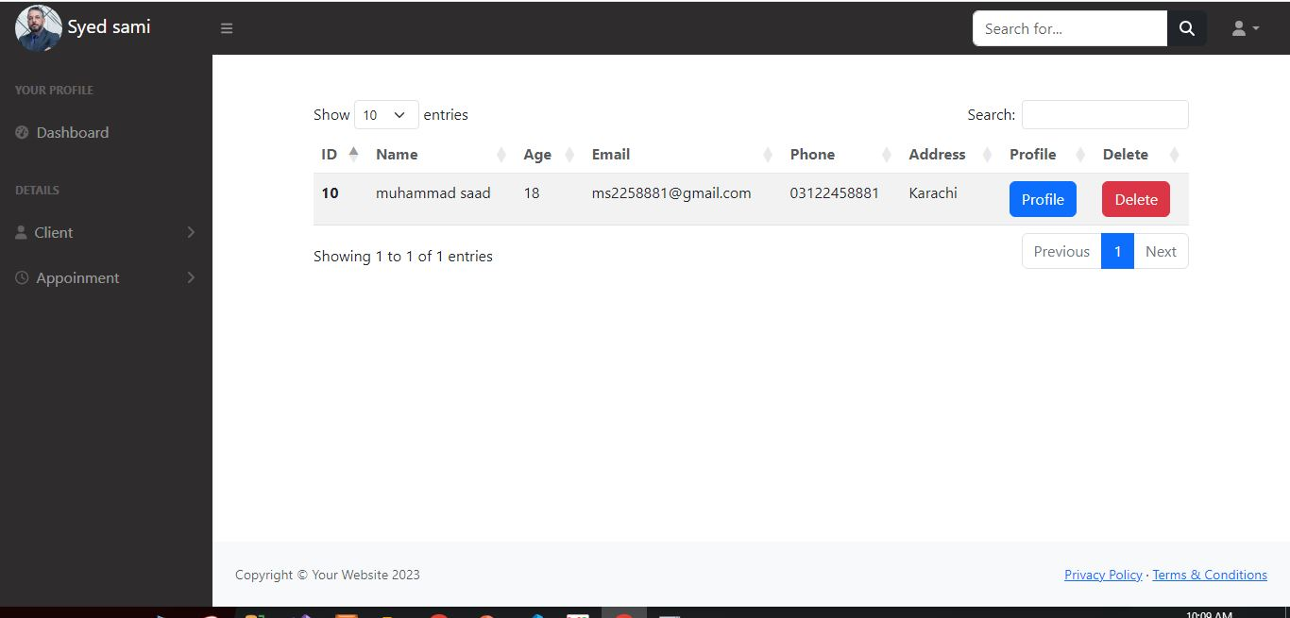

**SCREENSHOTS**

**LOGIN:**

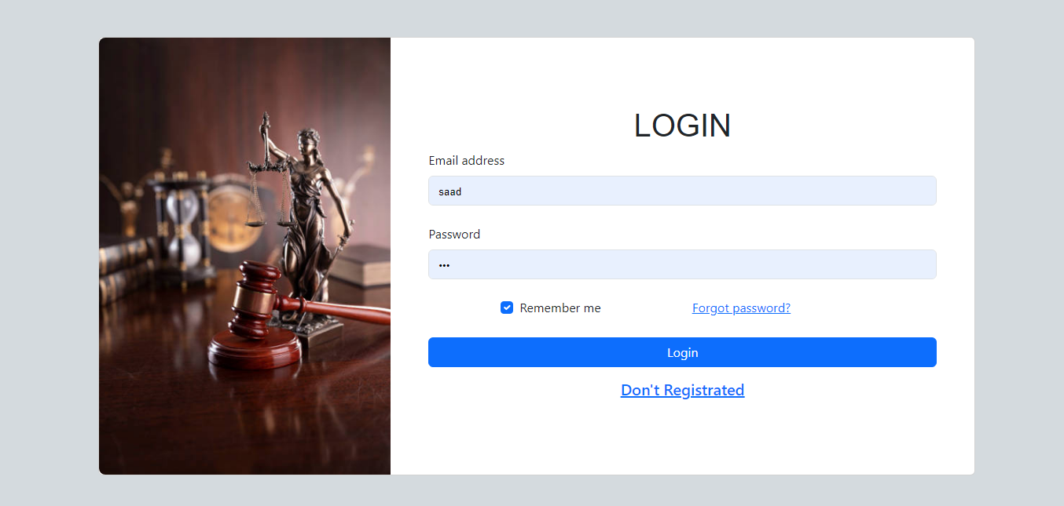

**LAWYER**

**REGISTER:**

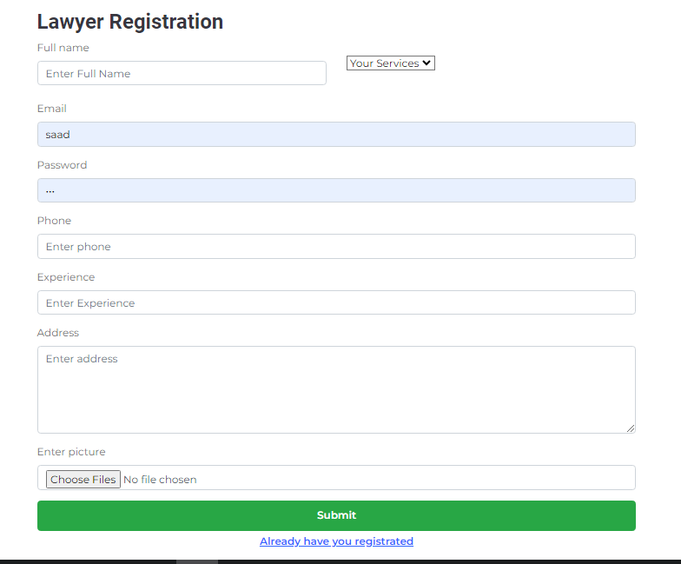

**CLIENT**

**REGISTER:**

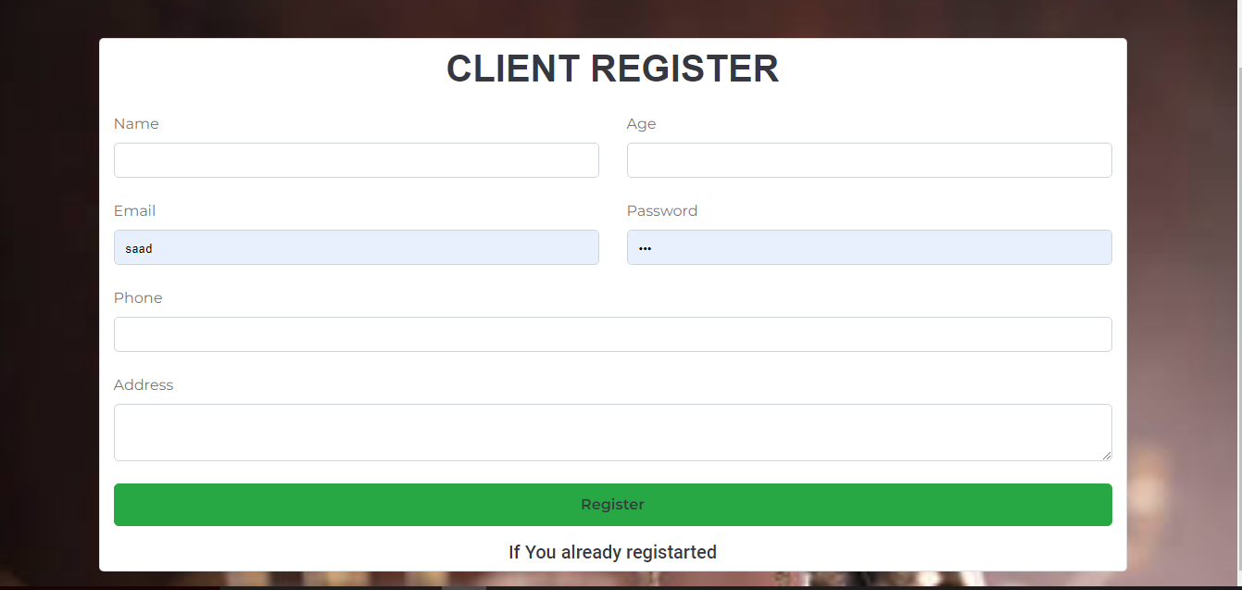

**HOME:**

Here a Home Page.



**ABOUT US:**

About information are as following:

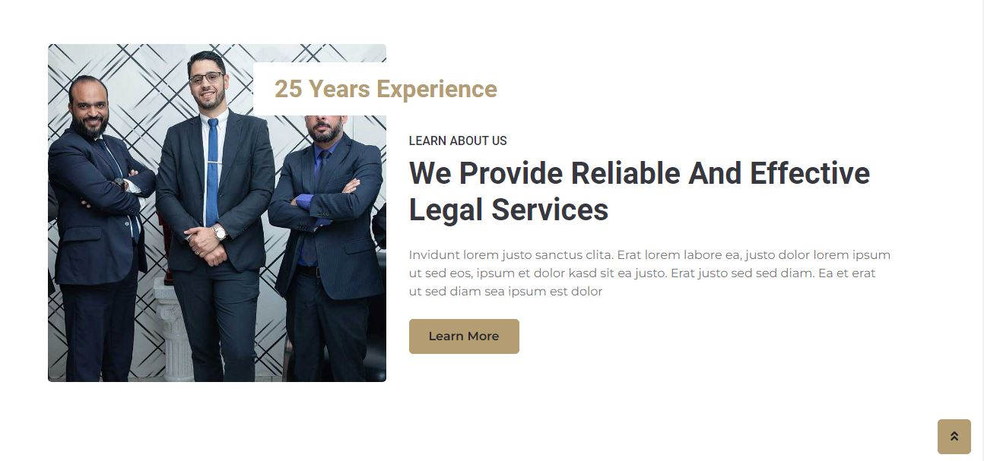

**HEADER:**

Here is header.



**FOOTER:**

Here is Footer.

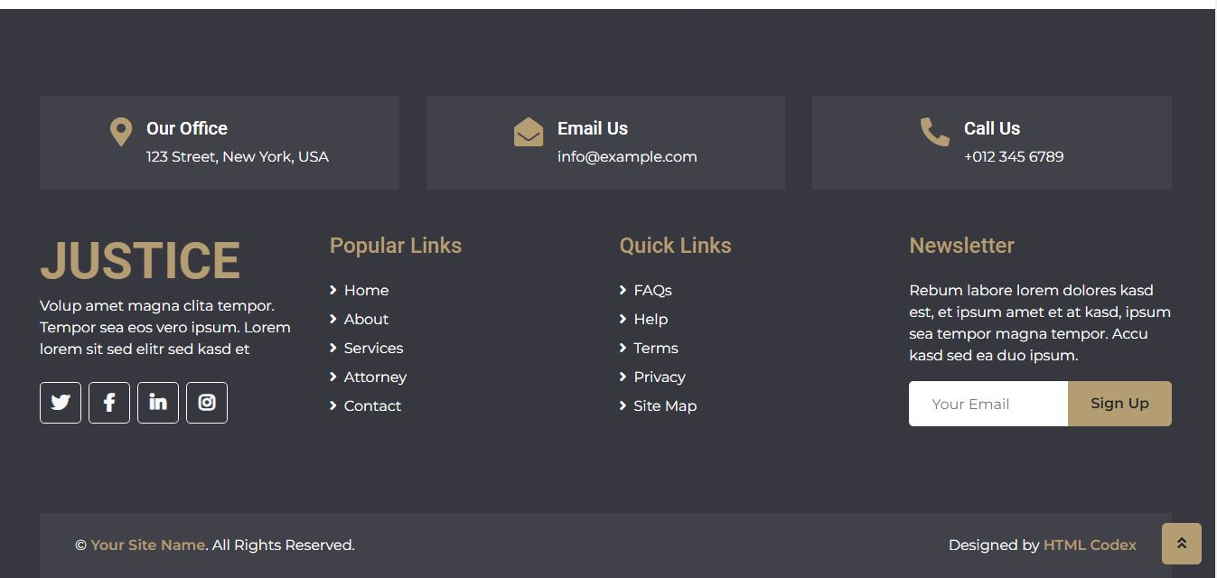

**PRACTICE:**

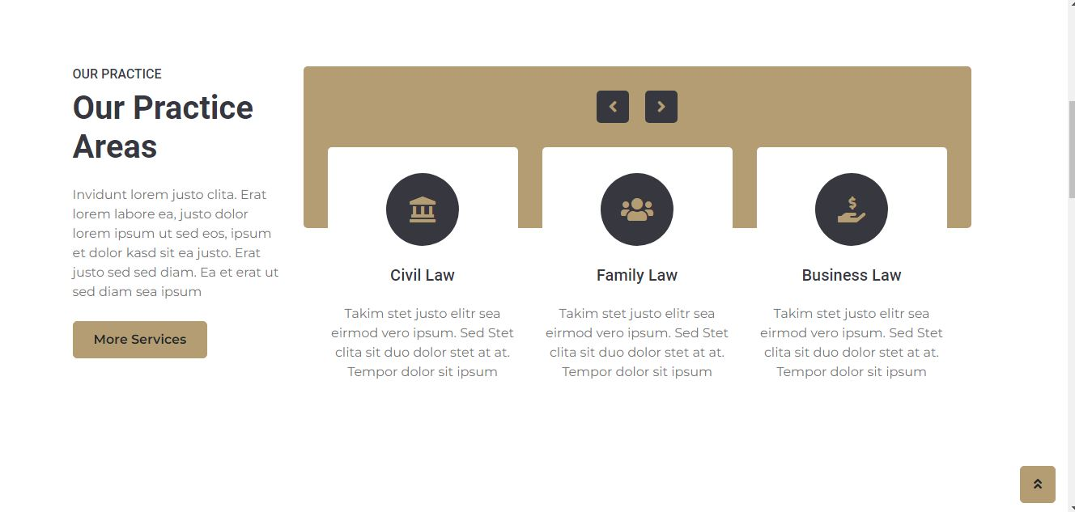

**ATTORNEYS:**

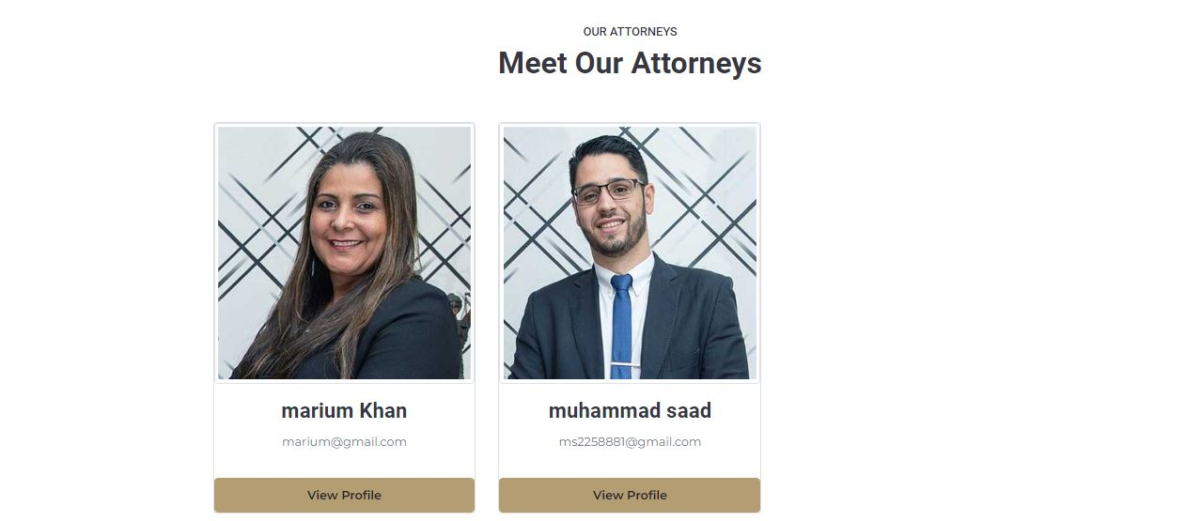

**CONTACT:**

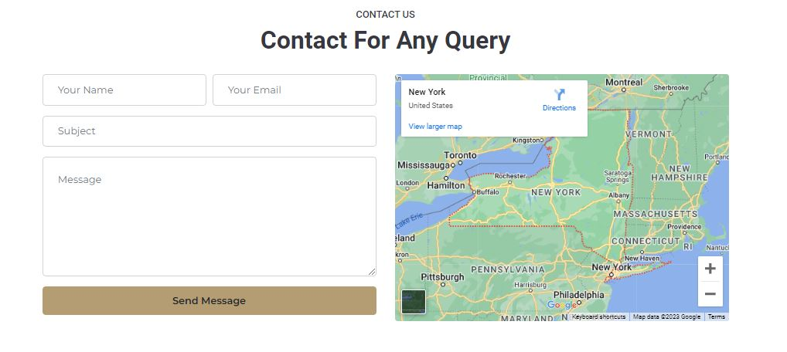

**CIVIL LAW**

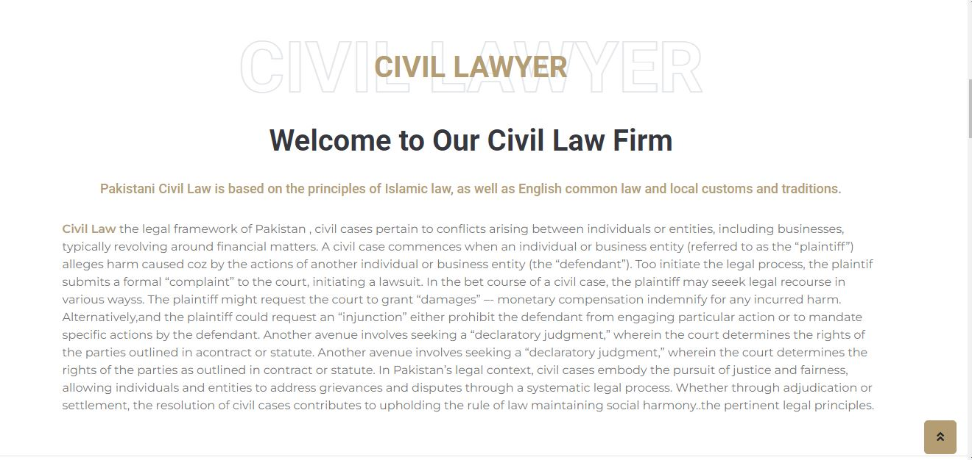

**CORPORATE LAW**



**DIVORCE LAW**

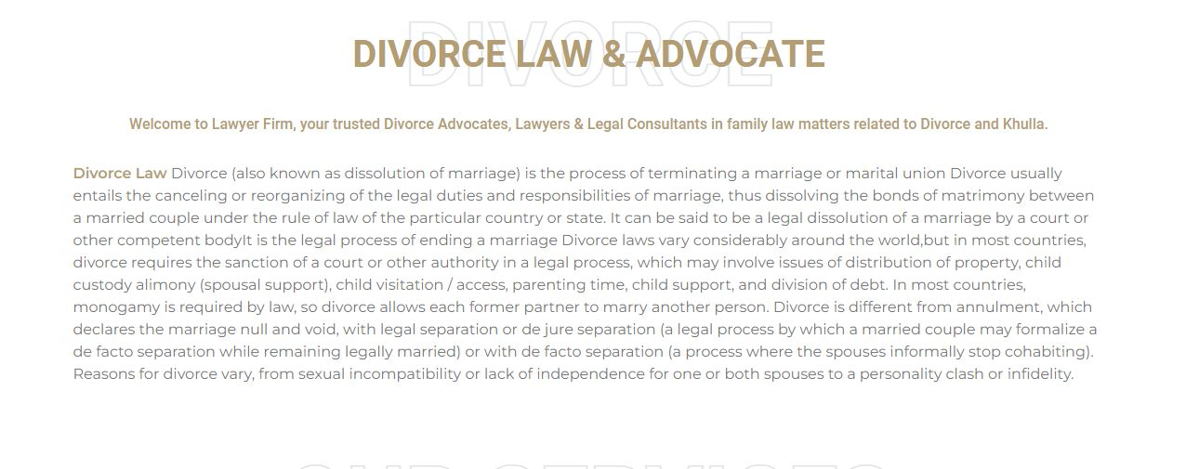

**CRIMINAL LAW**



